FICHIER DE PRESSE
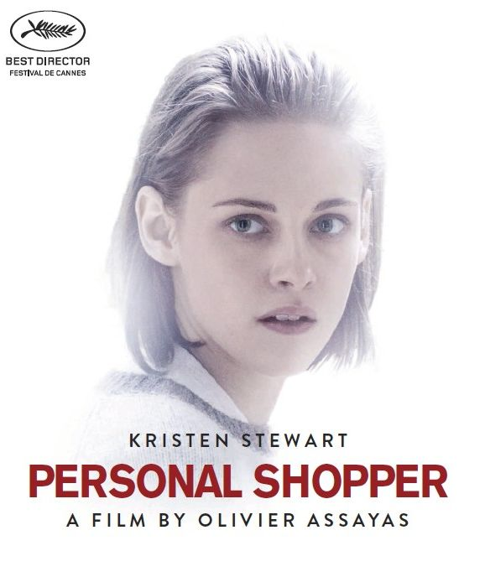

Sortie: 14 décembre 2016 | Durée: 102 minutes
Distributeur: The Searchers | Presse: Day One MPM

FACTSHEET

Titre original ‘Personal Shopper’

Réalisateur Olivier Assayas ('Clouds of Sils Maria')

Producenten

Genre Mystère

Langue Anglais, sous – titres Français

Durée 102 minutes

Keuring TBC

Logline Avec 'Personal Shopper' le réalisateur Olivier Assayas se situe à la frontière entre le thriller sensuel et le mystère élégant, dans le milieu parisien de la couture. Pour ce projet, Assayas se joint à nouveau à Kristen Stewart, après un 'Clouds of Sils Maria’ fort acclamé. Stewart a par ailleurs été récompensée d’un César pour son rôle dans ce film.

'Personal Shopper' a reçu à Cannes le prix de la meilleure mise en scène.

Synopsis La jeune américaine Maureen (Kristen Stewart) travaille de jour à Paris comme 'personal shopper' pour une célébrité exigeante. Elle passe ses nuits à rechercher un signe envoyé par son frère jumeau défunt, Lewis. Maureen en Lewis ont conclu un pacte, juste avant le décès de ce dernier, pour explorer ensemble les frontières de la mortalité. Lorsque Maureen commence à recevoir de mystérieux messages, elle est convaincue que Lewis n’y est pas étranger.

Casting Kristen Stewart, Lars Eidinger, Anders Danielsen Lie, Nora Von Waldstâtten, Sigrid Bouaziz

Date de sortie 14 décembre 2016

Distribution The Searchers, Theatrical België
Oostenstraat 50 B9, 2018 Antwerpen
Contact:
welcome@thesearchers.be
www.thesearchers.be

Presse & Publicité Day One MPM
Accent Business Park, Kwadestraat 153 bus 0.3, 8800 Roeselare
Contact: Tim Desmet/Koenraad Parrein
T: +32 (0)51 25 39 92
tim@dayonempm.be/ koenraad@dayonempm.be
www.dayonempm.be

LOGLINE

Avec 'Personal Shopper' le réalisateur Olivier Assayas se situe à la frontière entre le thriller sensuel et le mystère élégant, dans le milieu parisien de la couture. Pour ce projet, Assayas se joint à nouveau à Kristen Stewart, après un 'Clouds of Sils Maria’ fort acclamé. Stewart a par ailleurs été récompensée d’un César pour son rôle dans ce film.

'Personal Shopper' a reçu à Cannes le prix de la meilleure mise en scène.

SYNOPSIS

La jeune américaine Maureen (Kristen Stewart) travaille de jour à Paris comme 'personal shopper' pour une célébrité exigeante. Elle passe ses nuits à rechercher un signe envoyé par son frère jumeau défunt, Lewis. Maureen en Lewis ont conclu un pacte, juste avant le décès de ce dernier, pour explorer ensemble les frontières de la mortalité. Lorsque Maureen commence à recevoir de mystérieux messages, elle est convaincue que Lewis n’y est pas étranger.

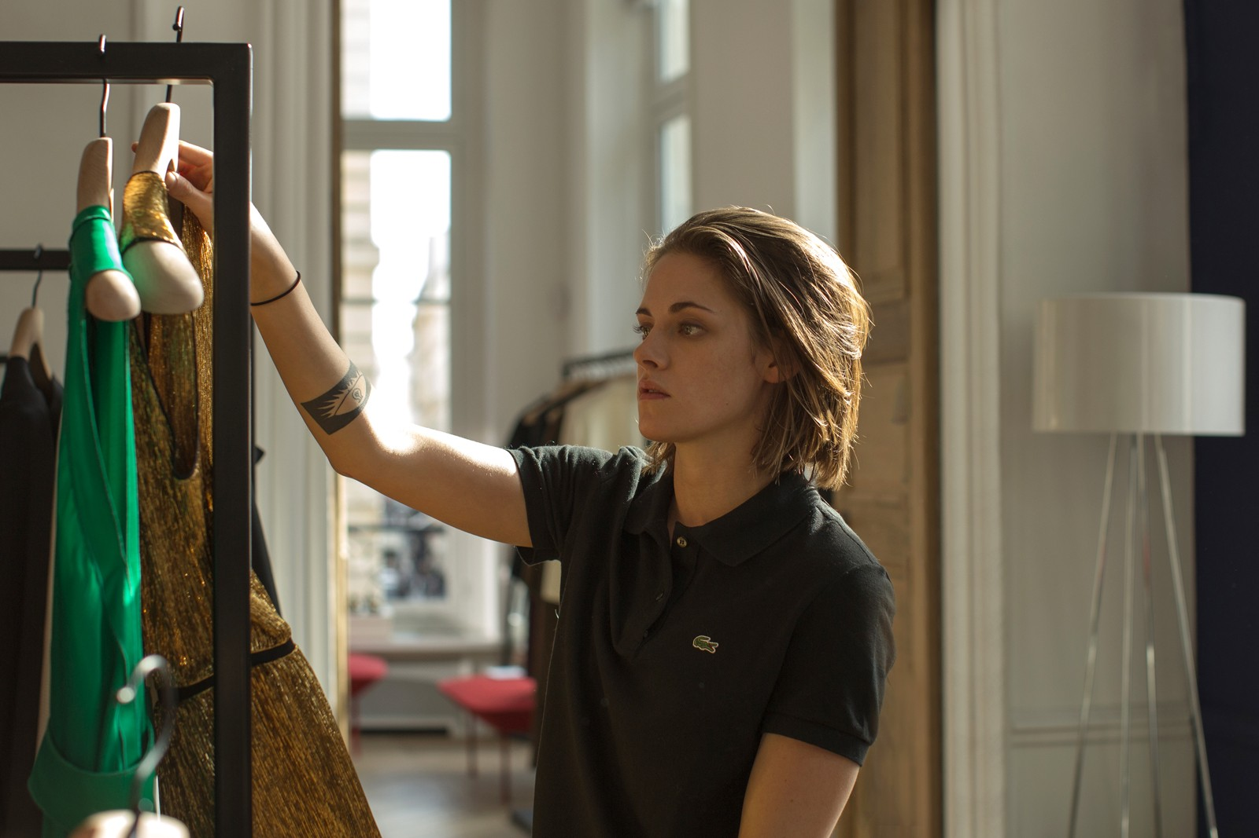

STORY

Maureen is a young American woman in Paris making her living as a personal shopper for a celebrity. Also, Maureen may have the psychic ability to communicate with spirits, just like her twin brother, Lewis, who recently passed away. She soon starts receiving ambiguous messages coming from an unknown source.

INTERVIEW WITH KRISTEN STEWART

/ Did you think you would work again with Olivier Assayas so quickly, only two years after Sils Maria?
No. But I knew he liked acting with the same people, actors and technicians. So, deep down, I hoped I would. We got along really well on the set of Sils Maria and I figured, sooner or later, we’d work again on a creative project. But I had no idea it would be so soon! I’m a good friend of Olivier’s producer, Charles Gillibert. He’s the one who told me Olivier was already working on a new script. I think we were in Cannes for Sils Maria. Honestly, it was the first time I’d ever met such a close-knit group of people who formed a real team. I didn’t want to leave. We were made for each other! I feel very lucky. So, when Olivier offered me the chance to act in Personal Shopper, I’ll admit I was excited, but not surprised. We really wanted to continue our experience as a group.

/ One gets the feeling that, in you, Olivier Assayas has not only found an actress, but also the ideal person to embody the kind of modern young woman he has always wanted to portray in his films. Can you say the same for him? That he’s director you’ve always been looking for?
Yes, hands down. We’ve both worked with a lot of people. But we share a non-verbal form of communication that is perfect in our profession. We don’t talk a lot, but we understand one another and share many of the same interests, as well as a similar type of curiosity. It’s a lot of fun to work with him.

/ How did Olivier Assayas come to you with Personal Shopper?
He told me he was writing a very simple script, and that he was writing it for me in the hopes I’d like it. When I received the script, I was really scared because it was hard for me to imagine calling up Charles or Olivier and telling them it wasn’t for me! Thankfully, that wasn’t the case at all. Once I read it, I was very impressed. It was so different from Sils Maria. For me, most of all! I thought I knew Olivier, but I couldn’t fathom how he’d come up with this story. It opened my eyes to the more hidden aspects of his personality. It’s a very contemplative film. In Personal Shopper,
Olivier is able to evoke invisible worlds in his own way without naming them. I think it’s a more personal film than Sils Maria. It isn’t analytical; it’s a sensual and deeply human film. Olivier is a cerebral filmmaker who was able to express very private emotions in this film. It was really cool. I hadn’t felt that from him in Sils Maria.

/ Personal Shopper examines uncommon themes in French cinema, like ghosts or spiritism, while remaining quite different from American thrillers involving the supernatural.
Yes. In Sils Maria, Maria, played by Juliette Binoche, and my character, Valentine, are having a conversation about movies. They disagree on a film they’ve just seen about mutants in space. Valentine says there’s just as much truth in fantasy or sci-fi than in a lot of supposedly “more serious” films. These movies use symbols and metaphors – but that doesn’t make them more superficial. They ultimately talk about the same things and examine the same subjects explored by openly psychologi- cal films. It’s funny to think that Olivier literally based his following film on a line of dialogue from Sils Maria. Personal Shopper is also a genre movie, which sets it apart from most French auteur films. It’s a genre film that doesn’t try to scare us with ghosts but, instead, offers a reflection on reality. The film also asks what, in my opinion, is the most terrifying question in life: “Am I completely alone, or can I truly enter into contact with someone else?”

/ What was the most difficult aspect of working on Personal Shopper ?
I play a young woman who is ver y lonely, completely isolated and sad. It was exhausting to be in that character all the time. Even when I was in a scene with other actors, I could never really be with them. It’s as if they were all ghosts. I didn’t consider myself to be a finite person. There couldn’t be the slightest interaction between me and them because I didn’t really feel like I existed. That plunged me into a very painful state. Thankfully, I was surrounded by people I love and never felt alone. I was very lucky. If the atmosphere on set hadn’t been as positive or friendly, I would have been devastated and probably collapsed on the floor. In the film, I never stop rushing from one place to another. I’m in constant movement. I lost a lot of weight during the shoot. It was exhausting.

/ Maureen hates her status as “personal shopper,” as well as her rich and famous boss. But she can’t help tr ying on this woman’s clothes, transgressing different taboos – and have fun doing it.
Maureen is fascinated by the same thing she hates. She is going through an identity crisis. I love the fact that she is not shown as a feminist critici- zing the superficiality of consumer society. She is going through an internal struggle. She is very attracted to this world, where her career is starting to take shape. But she is ashamed of this attraction. I’ve felt this at times, as we all have to a certain degree. The story takes place in the world of contemporary fashion, but it could have taken place in 1930s Hollywood. I don’t know if things were worse or better back then. People have always been attracted to all that glitters. Like tiny moths.

/ Personal Shopper deals with mourning. But it’s also the story of a young woman’s emanci- pation, trying to find freedom by taking a very strange path.
Yes. The greatest periods of my life have always been preceded by disasters. Moments of serenity or fulfillment often follow traumatic events. You feel more alive if you’ve had a brush with death. At the end of the film, even if she hasn’t found what she was looking for, Maureen is ultimately able to start over.

/ How did you prepare for the role of Maureen? And, how important is the physical appearance of your characters for you?
Absolutely important. I wanted people to feel like Maureen was a twin looking for the symbiosis she lost when her brother died. So, I imagined her to have a very simple, almost androgynous look. Her appearance also reflects her love-hate relationship with the fashion world. Therefore, the choice of clothing was very important. Regarding the preparation of the film, I always only read a script once, then refuse to look at it again. That way, I discover the scenes everyday on set. I didn’t have anything to learn in particular for the film. Olivier wanted to shoot earlier in the year so I could follow up with the Woody Allen film, where I play a young, charming, feminine, and joyful girl. I felt incapable of doing both films in that order. I knew that – after everything I’d go through for Personal Shopper – I’d be ravaged and none too pretty by the end of the shoot! I didn’t really prepare, but I knew where to look for what I needed. I knew where to find the trigger, and all I had to do was pull. I was ready to do it for the film.

/ You filmed in the streets of Paris with the crew of Personal Shopper 48 hours before the November 13th attacks. It’s hard not to think of that while watching the film, which seems to be charged with a tension and anxiety specific to our time.
When I see the film, I tell myself that we’re all in our own world, completely absorbed by things that concern us, and us alone. Maureen is so consumed by her obsessions that she pays almost no attention to the people and things around her. She isn’t really in Paris, or anywhere for that matter. It hurts when I watch the film, which portrays a character running around Paris – a city that’s about to be terribly wounded – without ever experiencing even the slightest pleasure. It’s very painful and poignant. I hate to put it in these terms, but we were lucky. The day after November 13th, we had to start a new day of shooting, but it was nearly impossible to work. Everything seemed so fake. Shooting a film in a studio…

/ Before your two films with Olivier Assayas, what was your relationship to French cinema?
I’d seen a few essentials, like Breathless and Jules et Jim. Charles, Olivier and the whole crew opened my eyes to a new world of film screenings and cinephilia. I discovered a lot of French films on DVD. It was a unique experience for an American actress to suddenly find herself to be part of that universe. It’s really cool. In Hollywood, everyone shares the same values. Here, in France, it’s much more disparate and feverish. In the US, films are made to entertain and make money. Auteur or art films occupy a tiny sliver of the industry. Ultimately, the filmmakers I like best in the US are those who share a certain idea of film that is closer to some European and French auteurs. In France, one’s motives for making a film are not the same as in Hollywood. There’s a desire to take risks, unlike big-budget American movies, which are only interested in repeating tried and tested ideas.

VICTOR HUGO AND SPIRITISM

Less than ten days after Louis- Napoléon Bonaparte’s coup d’état, Victor Hugo decided to go into exile on December 11th 1851. An exile
that would last nineteen years. In August 1852, he moved to the island of Jersey and settled into a large house overlooking the ocean called “Marine Terrace.” Here, between September 1853 and October 1855, he communicated with spirits everyday. The American trend of table-turning séances came to France in early 1853, and that same year, Delphine de Girardin introduced Hugo to spiritism. During one such séance on the evening of September
11th, he was visited by his daughter, Léopoldine, who had drowned years earlier. The accuracy of this contact with the Afterlife convinced the poet
of its authenticity.

From that moment on, he would dialogue with the greatest minds of the past: Dante, Galileo, Shakespeare, Plato, Jesus, or Alexander the Great. And also with more abstract entities, like Drama, Death, “the Shadow of the Sepulchre,” the Idea…
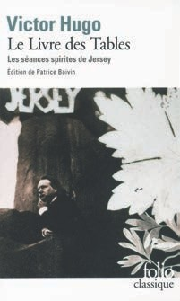
A total of over one hundred spirits would visit and comfort Hugo in his poetic, philosophical, religious, and metaphysical intuitions. And breathe new life into his inspiration. The minutes of these dialogues were transcribed into four notebooks, only three of which have survived. They were collected in a work that held great importance for Hugo called Conversations with Eternity, which he chose not to publish during his lifetime. Until his final hour, he maintained his faith in the survival of the soul.

HILMA AF KLINT
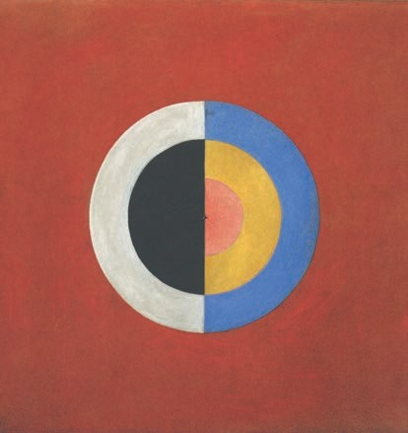
Hilma af Klint (1862-1944) can be counted among the greatest artists of the 20th century, and was a pioneer of abstract art several years before Kandinsky, Mondrian or Malevich. She was also one of the rare female artists of her generation to have as radical an approach to her creativity. As early as 1906, Hilma af Klint broke away from figurative painting after being influenced by spiri- tualism and theosophy. Through her art, she tried to grasp undiscovered dimensions beyond tangible reality. Along with other pioneers of abstraction, she shared a fascination for the occult and the spiritual dimensions art, all of which is manifested in her powerful and enigmatic compositions.

As a medium, she was convinced her works were dictated to her from the Hereafter. “The pictures were painted directly through me without preliminary drawings and with great power. I had no idea what the pictures would depict. And, still, I worked quickly and surely without changing a single brush stroke.” Despite the fact that Hilma af Klint’s body of work includes over one thousand paintings and sketches, she has remained largely unknown. Because she felt they were too audacious, her abstract paintings were never exhibited during her lifetime. Klint’s last will and testament imposed a twenty year waiting period after her death before they could be shown, since she was convinced they could not be understood any sooner. This is why recognition of her work, which now forces historians to rewrite the birth of abstraction, came so late. Though her art was revealed to the public for the first time in 1986, she was only fully appreciated in 2013 after a vast retros- pective was held at the Moderna Museet in Stockholm, which also toured to several other museums. Her modernity is just as relevant today and seems more at home in the 21st century. One might say that, one hundred years ago, Hilma af Klint painted for the future.
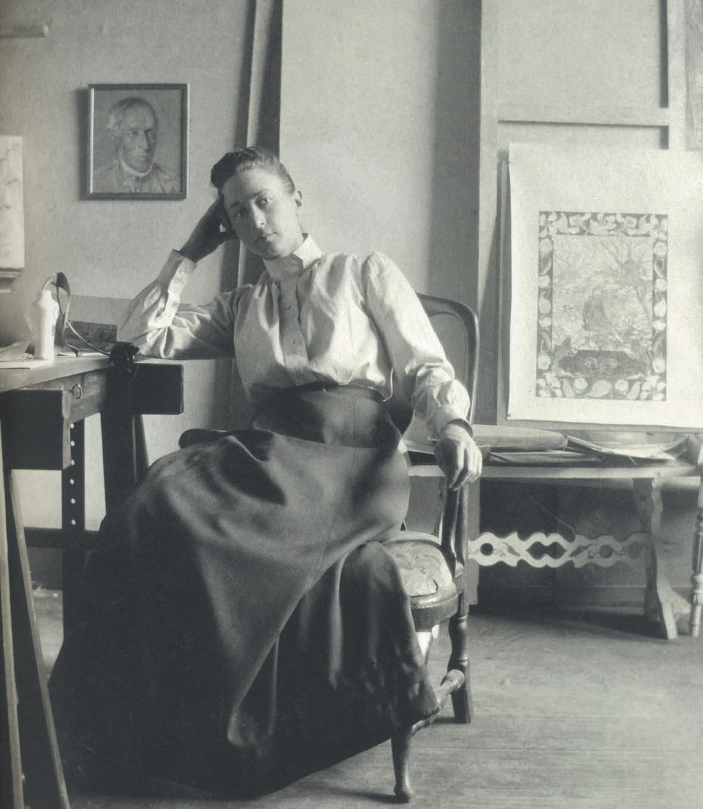
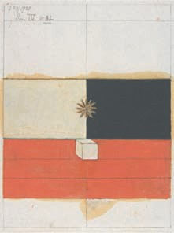

CREW

Written and directed by Produced by Executive producer Co-produced by  Director of Photography Production Designer Sound Design | Olivier Assayas Charles Gillibert Sylvie Barthet  Artemio Benki, Fabian Gasmia  Yorick Le Saux  François-Renaud Labarthe Nicolas Cantin, Nicolas Moreau, Olivier Goinard
Costume Designer Editor Casting  Assistant Director Screenplay Make up Hair Design | Jürgen Doering Marion Monnier Antoinette Boulat Dominique Delany Christelle Meaux  Thi Than Tu Nguyen  Morgane Bernhard
A CG Cinéma Co-production with Vortex Sutra, Sirena Film, Detail Films, Arte France Cinéma and Arte Deutschland/WDR
With the participation of Arte France, Arte Deutschland/WDR, Canal +, Ciné + With the support of the Czech Tax rebate, the Czech Minority Coproduction Fund, the Tax Shelter of the Belgian Federal Government via Scope Invest
International Sales mk2 films

CAST

Maureen Ingo Lara Erwin Gary  Policeman  Kyra  Victor Hugo | Kristen Stewart Lars Eidinger Sigrid Bouaziz  Anders Danielsen Lie  Ty Olwin  Hammou Graïa  Nora Von Waldstätten  Benjamin Biolay
Cassandre  Jérôme  Chanel Press Agent London couture house Press Agent Paris couture house Press Agent Photo Shoot Assistant Photographer  Cardiologist | Audrey Bonnet Pascal Rambert Aurélia Petit Olivia Ross Thibault Lacroix Calypso Valois Benoit Peverelli Dan Belhassen
Kyra’s Lawyer  Hotel Receptionist | Léo Haidar  Mickaël Laplack
Cartier Salesman Louboutin Receptionist Oman Driver Saleswoman | Vianney Duault Célia Ouallouche Khaled Rawahi Julie Rouart

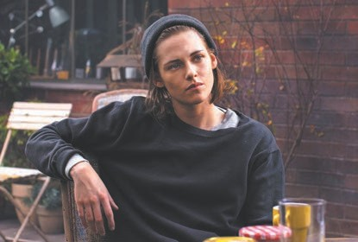
KR I STE N STEWART

2016 - Personal Shopper by Olivier Assayas Cafe Society by Woody Allen • Billy Lynn's Long Halftime Walk by Ang Lee • 2015 - Still Alice by Wash Westmoreland & Richard Glatzer • American Ultra by Nima Nourizadeh • 2014 - Clouds of Sils Maria by Olivier Assayas • Anestesia by Tim Blake Nelson • Camp X-Ray by Peter Salter • 2012
Photo © Carole B ethuel
Photo © Carole B ethuel
- The Twilight Saga: Breaking Dawn – Part 2 by Bill Condon • Snow White and the Huntsman by Rupert Sanders • On the Road by Walter Salles
2011 - The Twilight Saga: Breaking Dawn – Part 1 by Bill Condon • 2010 - The Twilight Saga: Eclipse by David Slade • The Runaways by Floria Sigismondi • 2009 - The Twilight Saga: New Moon by Chris Weitz • 2008 - Twilight by Catherine Hardwicke • 2007 - Into the Wild by Sean Penn • 2002 - Panic Room by David Fincher
Photo © Carole B ethuel

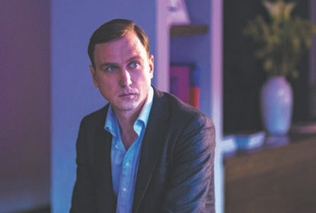
LAR S E I D I NG E R

2016 - Personal Shopper by Olivier Assayas
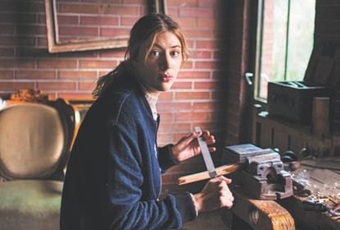
2015 - Dora or The Sexual Neuroses of Our Parents by Stina Werenfels • 2014 - Clouds of Sils Maria by Olivier Assayas • 2012 - Goltzius and the Pelican Company by Peter Greenaway • Home for the weekend by Hans-Christian Schmid • 2011
- Fenster zum Sommer by Hendrik Handloekten Hell by Tim Fehlbaum • Code blue by Urszula Antoniak • Tabu by Christoph Stark • 2010 - Video nasty by Jörg Buttgereit • 2009 - Alle Anderen by Maren Ade • 2007 - After Effect by Stephan Geene
Photo © Carole B ethuel
2005 - See You at Regis Debray by C.S. Leigh

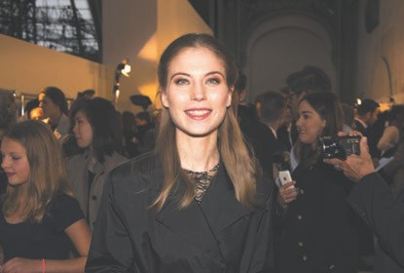
NORA VON WALD STÄTTE N

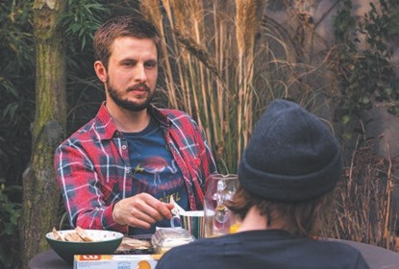
2016 - Personal Shopper by Olivier Assayas Griessnockerlaffäre by Ed Herzog • 2015 - Die wilde Maus by Joseph Hader • Die dunkle Seite des Mondes by Stephan Rick • Life Eternal by Wolfgang Murnberger • 2014 - Clouds of Sils Maria by Olivier Assayas • 2013 - Oktober November by Götz Spielmann • Woyzeck by Nuran David Calis • 2010 - Carlos by Olivier Assayas

AN D E R S DAN I E LS E N LI E

2016 - Personal Shopper by Olivier Assayas
2015 - This Summer Feeling by Mickaël Hers •
2014 - Fidelio, Alice’s Odyssey by Lucie Borleteau
2011 - Oslo, 31. August by Joachim Trier • 2006
- Reprise by Joachim Trier • 1990 Herman by Erik
Gustavson

SIGRID BOAUZ IZ

2016 - Personal Shopper by Olivier Assayas
2014 – Eden by Mia Hansen-Løve. 2013 Tunnel (tv series)

OLIVIER ASSAYAS

2016 - Personal Shopper
2014 - Clouds of Sils Maria
2012 - Something in the Air
2010 - Carlos
2008 - Summer Hours
2008 - Eldorado (documentary)
2007 - Boarding Gate
2007 - To Each His Own Cinema (short)
2006 - Paris, I Love You (short)
2005 - Noise (musical documentary)
2004 - Clean
2002 - demonlover
2000 - Sentimental Destinies
1999 - Late August, Early September
1997 - HHH, Portrait of Hou Hsiao-hsien
1996 - Irma Vep
1994 - Cold Water
1993 - A New Life
1991 - Paris Awakens
1989 - Winter’s Child
1986 - Disorder
BIBLIOGRAPHY

2014 - Assayas par Assayas (Conversations avec Jean-Michel Frodon)
2009 - Presence
2005 - Teenage years after May 1968
1999 - Tribute to Kenneth Anger
1990 - Conversation with Bergman (in collaboration with Stig Björkman)
1984 - Hong-Kong cinema (in collaboration with Charles Tesson)

